README for CBAT TEST DB – Olivia Smith

***THIS IS NOT FINAL AS MANY CHANGES WILL LIKELY HAPPEN***

Developer’s Note
This is a TEST file for the overall CBAT Course Database I am working on for Project 2. This is NOT the full database; however, the structure is the same as the final result will likely be. The ERD for the database has changed slightly to account for a few typos and missed items but is basically the same.
This was made in DB Browser for SQLite and I encourage you to view it in the same application to get a better understanding of the structure if you need it. PLEASE do not make permanent changes to the file without consulting me or other group members. I do not claim this file to be perfect so if you encounter any errors, PLEASE let me know as soon as possible.

About the File

As mentioned, this is a shortened version of the work-in-progress database for this project. The structure is the same as discussed before and more information about it can be found below. This is meant to ONLY be for testing purposes and I will hopefully put out the full thing in the near future.
The data in the file is only the courses starting with the “ACCT” prefix, or the accounting courses. Some of these courses have prerequisites that are not yet in the database yet but they will be added later on. There are no courses with corequisites.
There are two entries to the degree table which are both related to accounting. I have input the courses associated with them at this point in time in the degree_course table. With that, all courses that have prerequisites are listed in the course_requisites table. Note that if a course has multiple prerequisites, they are separate entries even if not ALL of them are required (so regardless of it is an AND or an OR). For example, ACCT-3010 requires ACCT-2010 and ACCT-2020, so the entries in the course_requisites table will look like this:

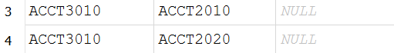
Note that the prerequisite or corequisite courses for a course will NOT show up in the course table as a foreign key. To view all information relating to a course, including prerequisites, you will likely need to do a join between tables or do certain select statements within the code. This was not my first choice but that is the only way this could work. If you have concerns about this, please let me know.
Entity Relational Diagram

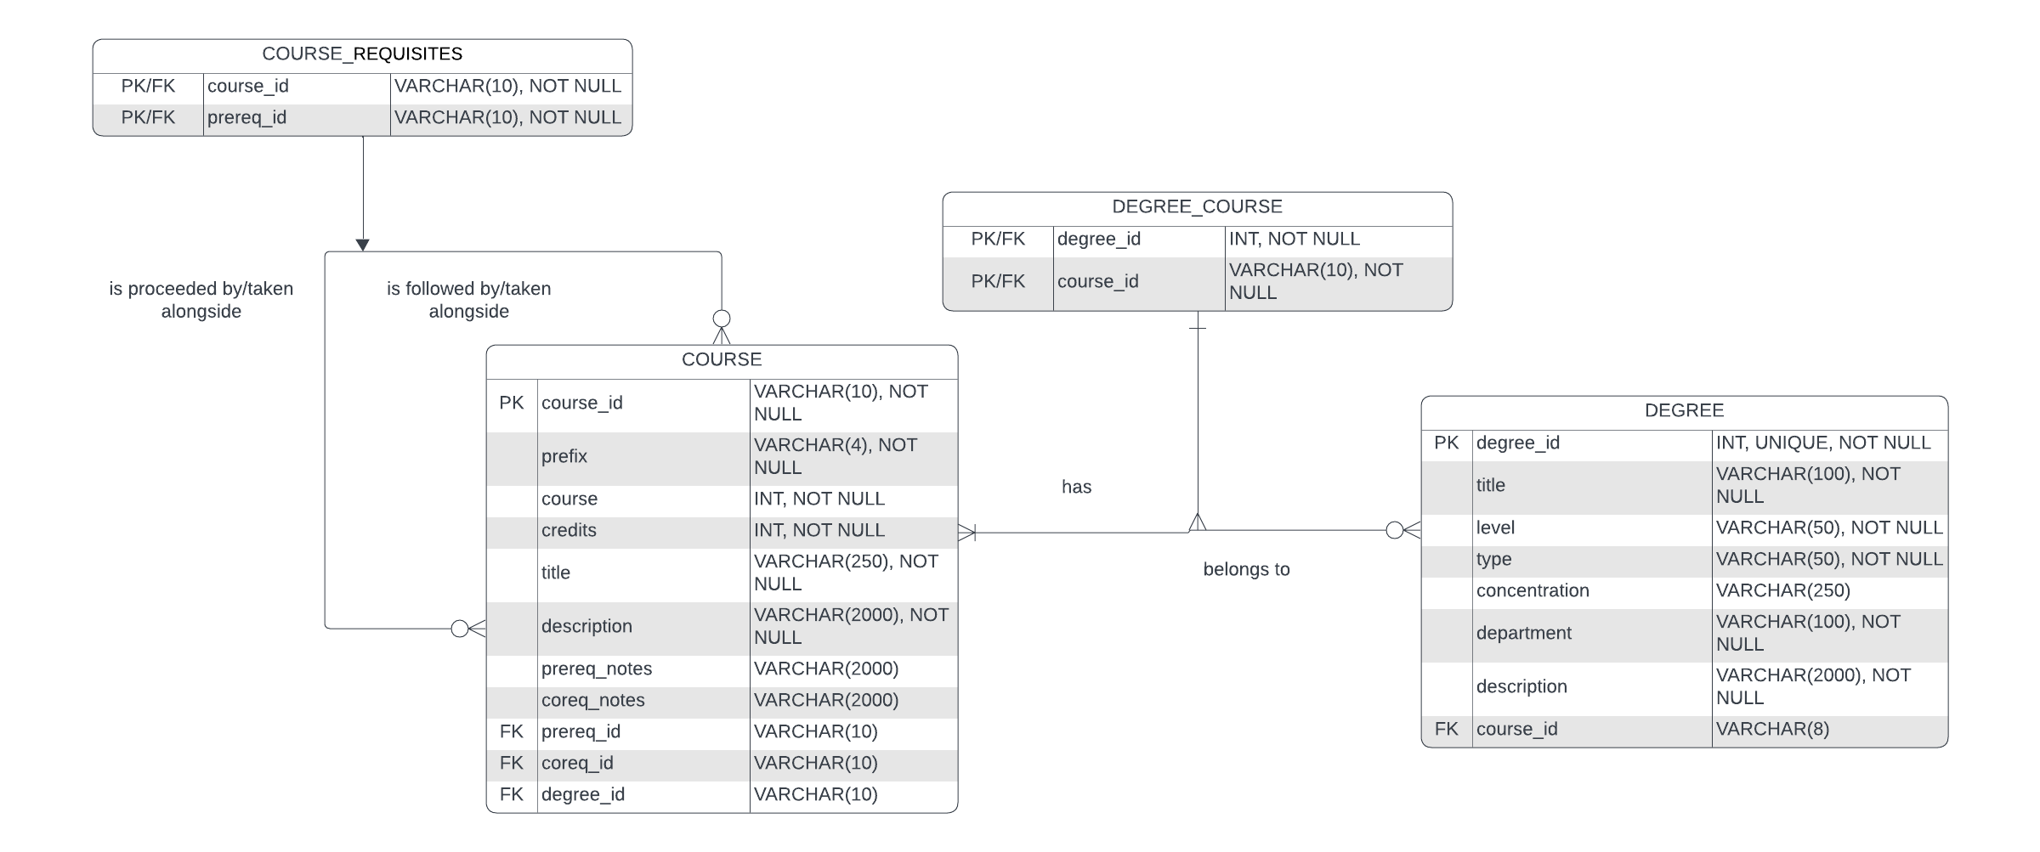

Structure Assumptions

- A COURSE can have zero to many prerequisite COURSES
- A prerequisite COURSE can proceed zero to many COURSES
- A DEGREE can have one to many COURES
- A COURSE can belong to zero to many DEGREES
Structure Notes

Regarding COURSE
A self-referencing many-to-many relationship is used with the course table to account for prerequisite courses. As a course can have no or multiple prerequisites, it can also account for any of those situations. As with any many-to-many relationship, it includes an associative entity, COURSE_PREREQUISITIES
The foreign keys on the course table are not tagged with “NOT NULL” due to some courses not having any prerequisites or corequisites. Therefore, this is optional and a key reason why on both ends of the relationship it is defined as zero-to-many.

Regarding DEGREE
A many-to-many relationship is used connect the degree table to the course table. As a degree would (clearly) require at least one course to any number of courses, it is one-to-many. The same is true for relating course back to degree, as a course can be associated with any degree, however it is not a hard requirement. Therefore, on that side it is zero-to-many. Like with course, it has an associative entity, DEGREE_COURSE.

A Note on Corequisites Courses
Corequisites courses are courses that must be taken at the same time as another course and are similar to CSCI-1100 lecture and its associated lab course. While they exist within our school, they are rather uncommon. However, the self-referencing many-to-many relationship for the course table will handle them the same as prerequisites are handling and there should be little problem with it. In the event that there is a problem due to corequisite entries, it is likely that they can be omitted.

